Information and dataset

1. Calculation algorithm

* Level 1

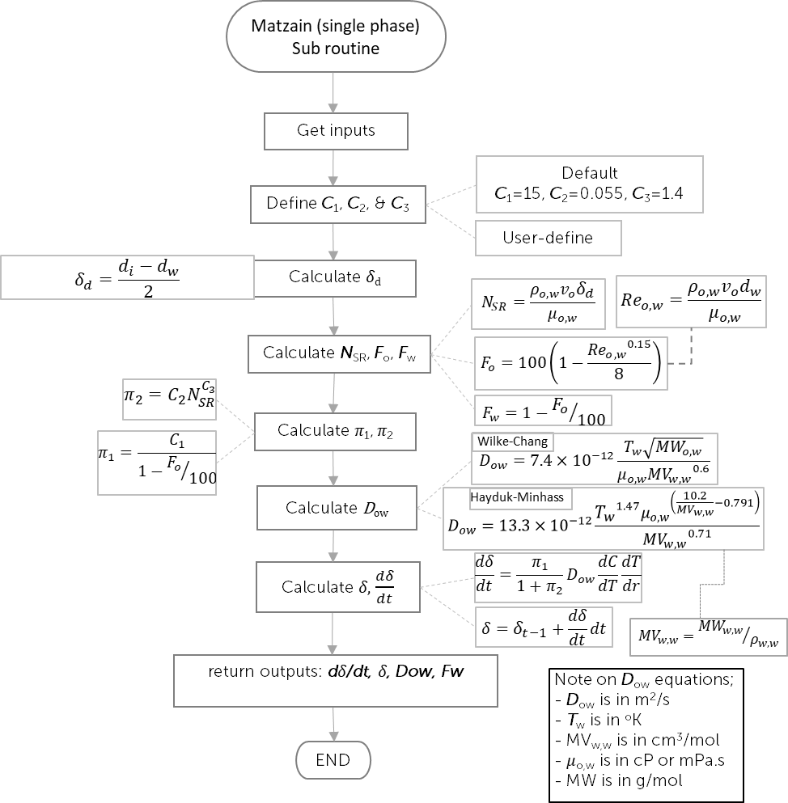

* Level 2

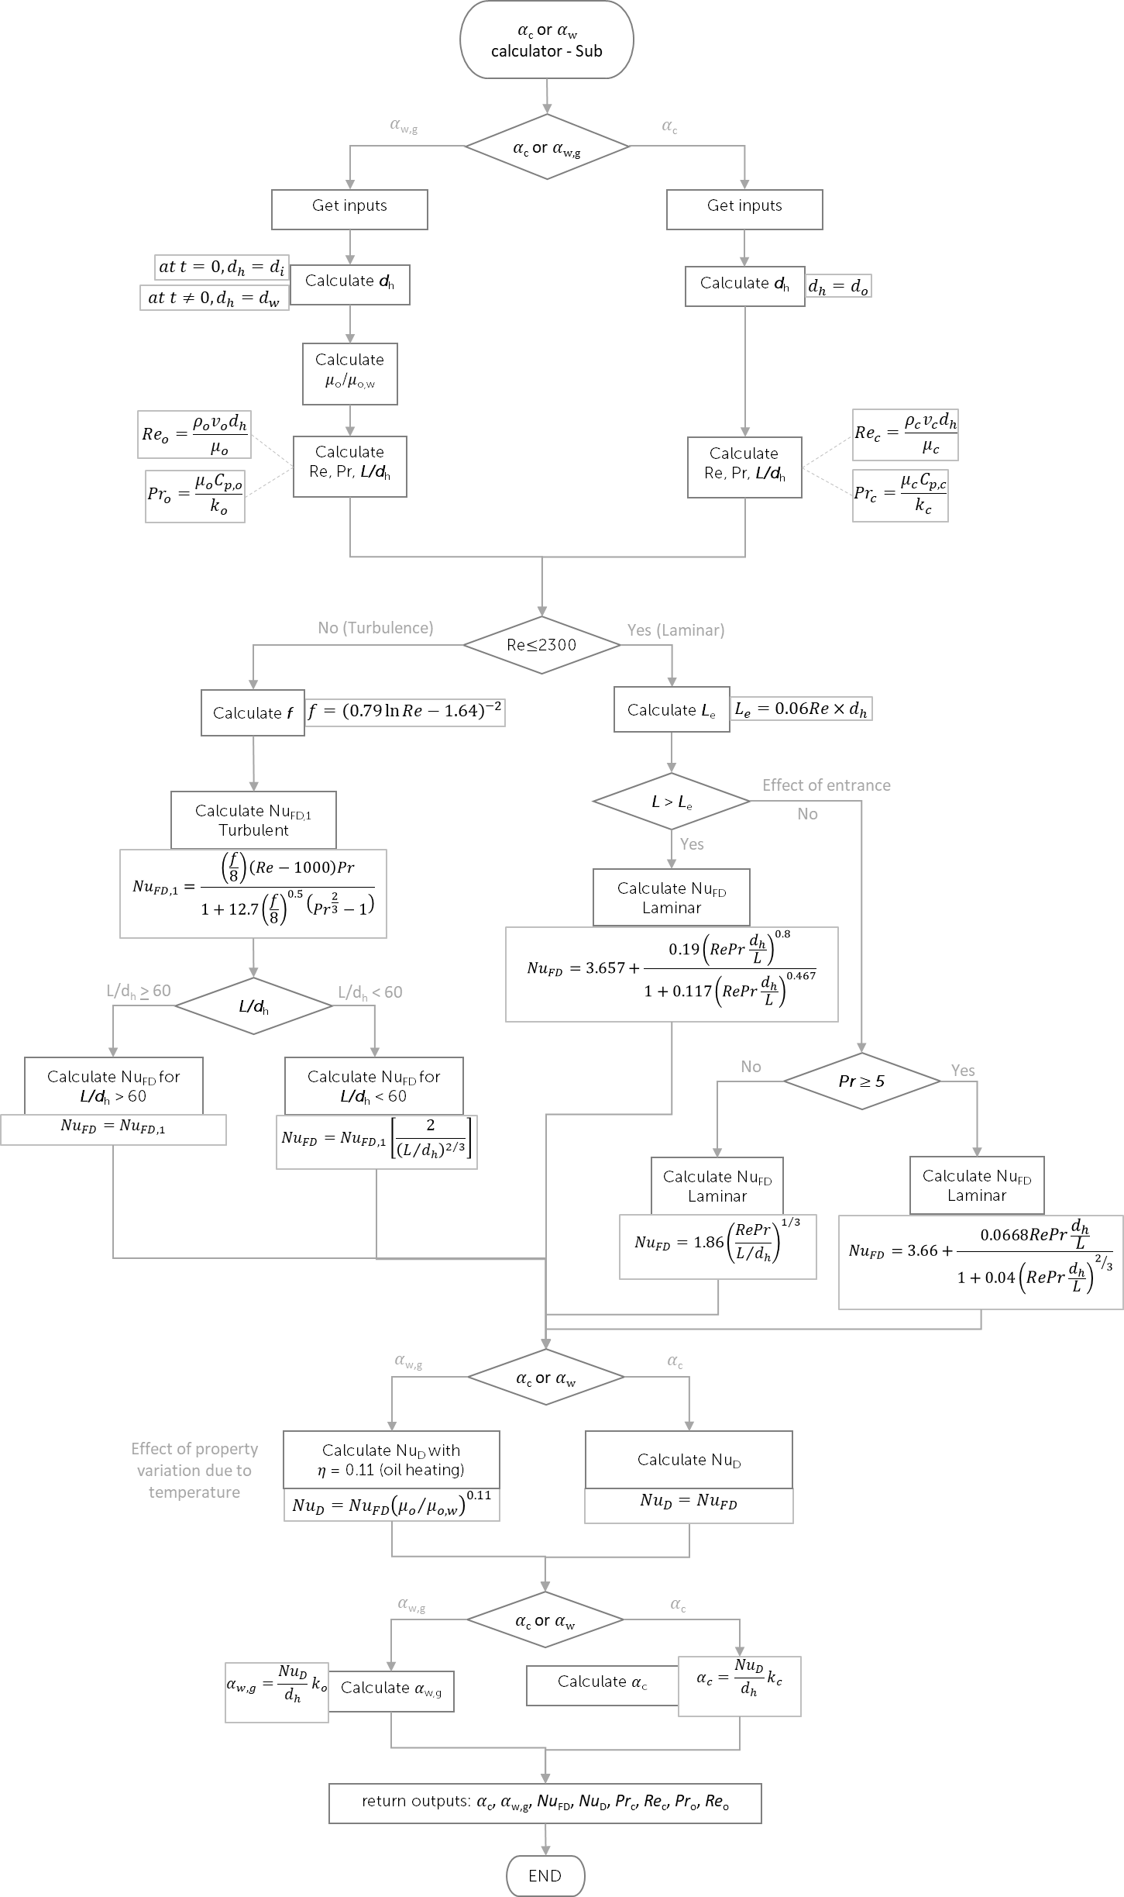

1. Fluid and wax files from selected waxy crude oil

As per attached

1. Coolant table

|  |  |  |  |  |
| --- | --- | --- | --- | --- |
| Temperature | Density (𝜌c) | Dynamic Viscosity (𝜇c) | Specific heat (*Cp*c) | Conductivity (*k*c) |
| C | kg/m3 | Pa.s | J/kg.K | W/m.K |
| 5 | 1000 | 0.001519 | 4200 | 0.5576 |
| 10 | 999.7 | 0.001307 | 4188 | 0.5674 |
| 15 | 999.1 | 0.001138 | 4184 | 0.5769 |
| 20 | 998.2 | 0.001002 | 4183 | 0.5861 |
| 21 | 998.0 | 0.000980 | 4183 | 0.5878 |
| 25 | 997.1 | 0.0008905 | 4183 | 0.5948 |
| 27.76 | 996.3 | 0.000839 | 4183.000000 | 0.599326 |
| 30 | 995.7 | 0.0007977 | 4183 | 0.603 |
| 30.64 | 995.5 | 0.000788 | 4183.000000 | 0.603986 |
| 35 | 994 | 0.0007196 | 4183 | 0.6107 |
| 40 | 992.2 | 0.0006533 | 4182 | 0.6178 |
| 45 | 990.2 | 0.0005963 | 4182 | 0.6244 |
| 50 | 988 | 0.0005471 | 4181 | 0.6305 |
| 55 | 985.7 | 0.0005042 | 4182 | 0.636 |
| 60 | 983.2 | 0.0004666 | 4183 | 0.641 |
| 65 | 980.6 | 0.0004334 | 4184 | 0.6455 |
| 70 | 977.8 | 0.000404 | 4187 | 0.6495 |
| 75 | 974.9 | 0.0003779 | 4190 | 0.653 |
| 80 | 971.8 | 0.0003545 | 4194 | 0.6562 |
| 85 | 968.6 | 0.0003335 | 4199 | 0.6589 |
| 90 | 965.3 | 0.0003145 | 4204 | 0.6613 |
| 95 | 961.9 | 0.0002974 | 4210 | 0.6634 |
| 100 | 0.5896 | 0.00001227 | 2042 | 0.02506 |

1. Dataset

* Level 1

*d*i is equal to 44.6mm. For wax and fluid properties taken from wax and tab files, it should be taken at pressure of 1 atm. The oil mass flow rate for this case is 0.50369 kg/s. The simulation time is 300 minute (5 hours) with 10 minutes of time step. Oil inlet *T*o,i temperature is 46C. *T*o,i will be used to get oil density for calculating oil velocity. At t = 0, it is assumed to have negligible wax deposit layer (hence, set 𝛿 = 0 with d𝛿/dt = 0). Only 2 outputs, *D*ow and *F*w need to be calculated at t=0. At t ≠ 0, 4 outputs need to be calculated for at each time step.

|  |  |  |  |  |  |  |  |
| --- | --- | --- | --- | --- | --- | --- | --- |
| INPUTS | | | | OUTPUTS | | | |
| Time | Tw | dw | dT/dr | 𝛿 | Fw | d𝛿/dt | Dow |
| min | C | mm | K/m | mm | [-] | mm | m2/s |
| 0 | 32.918 | 44.600 | -26211.909 | 0.0000 | 0.070 | 0.0000 |  |
| 10 | 35.083 | 44.185 | -22641.954 | 0.2075 | 0.417 | 0.2075 |  |
| 20 | 35.755 | 44.020 | -21513.706 | 0.2901 | 0.429 | 0.0825 |  |
| 30 | 36.171 | 43.910 | -20808.414 | 0.3451 | 0.430 | 0.0550 |  |
| 40 | 36.470 | 43.826 | -20299.523 | 0.3871 | 0.431 | 0.0420 |  |
| 50 | 36.702 | 43.757 | -19901.731 | 0.4214 | 0.432 | 0.0343 |  |
| 60 | 36.891 | 43.699 | -19575.824 | 0.4506 | 0.432 | 0.0292 |  |
| 70 | 37.051 | 43.648 | -19300.295 | 0.4760 | 0.432 | 0.0254 |  |
| 80 | 37.189 | 43.603 | -19061.937 | 0.4987 | 0.433 | 0.0226 |  |
| 90 | 37.311 | 43.562 | -18852.122 | 0.5191 | 0.433 | 0.0204 |  |
| 100 | 37.419 | 43.525 | -18664.922 | 0.5377 | 0.433 | 0.0186 |  |
| 110 | 37.516 | 43.490 | -18496.074 | 0.5548 | 0.433 | 0.0171 |  |
| 120 | 37.604 | 43.459 | -18342.414 | 0.5706 | 0.434 | 0.0159 |  |
| 130 | 37.686 | 43.429 | -18201.527 | 0.5854 | 0.434 | 0.0148 |  |
| 140 | 37.760 | 43.402 | -18071.530 | 0.5992 | 0.434 | 0.0138 |  |
| 150 | 37.830 | 43.375 | -17950.926 | 0.6123 | 0.434 | 0.0130 |  |
| 160 | 37.894 | 43.351 | -17838.504 | 0.6246 | 0.434 | 0.0123 |  |
| 170 | 37.954 | 43.327 | -17733.272 | 0.6363 | 0.434 | 0.0117 |  |
| 180 | 38.011 | 43.305 | -17634.408 | 0.6474 | 0.434 | 0.0111 |  |
| 190 | 38.064 | 43.284 | -17541.221 | 0.6579 | 0.435 | 0.0106 |  |
| 200 | 38.115 | 43.264 | -17453.127 | 0.6681 | 0.435 | 0.0101 |  |
| 210 | 38.163 | 43.245 | -17369.586 | 0.6777 | 0.435 | 0.0097 |  |
| 220 | 38.208 | 43.226 | -17290.020 | 0.6871 | 0.435 | 0.0093 |  |
| 230 | 38.252 | 43.208 | -17214.067 | 0.6960 | 0.435 | 0.0090 |  |
| 240 | 38.293 | 43.191 | -17141.415 | 0.7047 | 0.435 | 0.0087 |  |
| 250 | 38.333 | 43.174 | -17071.682 | 0.7131 | 0.435 | 0.0084 |  |
| 260 | 38.371 | 43.158 | -17004.623 | 0.7212 | 0.435 | 0.0081 |  |
| 270 | 38.408 | 43.142 | -16940.050 | 0.7291 | 0.435 | 0.0079 |  |
| 280 | 38.444 | 43.126 | -16877.748 | 0.7368 | 0.435 | 0.0077 |  |
| 290 | 38.478 | 43.111 | -16817.490 | 0.7443 | 0.436 | 0.0075 |  |
| 300 | 38.511 | 43.097 | -16759.150 | 0.7516 | 0.436 | 0.0073 |  |

dC/dT needs to be calculated for each pressure point as per explained in the list of abbreviation. If the required dC/dT fall between two pressure points, the code should be able to do linear interpolation. Below is example calculation for dC/dT at the first pressure point in the wax file.

|  |  |  |  |  |  |  |
| --- | --- | --- | --- | --- | --- | --- |
| P | T | | Concentration of total Wax in Feed | Concentration of total dissolved Wax in liquid | Concentration of total precipitated Wax | dC/dT |
|
| Pa | C | K | mol/mol | mol/mol | mol/mol |  |
| 100,000 | -30 | 243.15 | 0.17271 | 0.003282153 | 0.169429 | 0.000370 |
| 100,000 | -26.21 | 246.94 | 0.17271 | 0.004683066 | 0.168028 |
| 100,000 | -22.41 | 250.74 | 0.17271 | 0.006592745 | 0.166119 | 0.000676 |
| 100,000 | -18.62 | 254.53 | 0.17271 | 0.00915383 | 0.163557 |
| 100,000 | -14.83 | 258.32 | 0.17271 | 0.012528999 | 0.160182 | 0.001149 |
| 100,000 | -11.03 | 262.12 | 0.17271 | 0.016894008 | 0.155817 |
| 100,000 | -7.24 | 265.91 | 0.17271 | 0.022425729 | 0.150286 | 0.001810 |
| 100,000 | -3.45 | 269.7 | 0.17271 | 0.029285565 | 0.143426 |
| 100,000 | 0.34 | 273.49 | 0.17271 | 0.037600607 | 0.135111 | 0.002591 |
| 100,000 | 4.14 | 277.29 | 0.17271 | 0.047445871 | 0.125265 |
| 100,000 | 7.93 | 281.08 | 0.17271 | 0.058832418 | 0.113879 | 0.003396 |
| 100,000 | 11.72 | 284.87 | 0.17271 | 0.071701689 | 0.101010 |
| 100,000 | 15.52 | 288.67 | 0.17271 | 0.085921214 | 0.086790 | 0.004052 |
| 100,000 | 19.31 | 292.46 | 0.17271 | 0.101276874 | 0.071434 |
| 100,000 | 23.1 | 296.25 | 0.17271 | 0.117456358 | 0.055255 | 0.004356 |
| 100,000 | 26.9 | 300.05 | 0.17271 | 0.134007795 | 0.038704 |
| 100,000 | 30.69 | 303.84 | 0.17271 | 0.150163796 | 0.022548 | 0.003654 |
| 100,000 | 34.48 | 307.63 | 0.17271 | 0.164012301 | 0.008699 |
| 100,000 | 38.28 | 311.43 | 0.17271 | 0.171120235 | 0.001591 | 0.000371 |
| 100,000 | 42.07 | 315.22 | 0.17271 | 0.172526879 | 0.000184 |
| 100,000 | 45.86 | 319.01 | 0.17271 | 0.172711309 | 0.000000 | 0.000000 |
| 100,000 | 49.66 | 322.81 | 0.17271 | 0.172711309 | 0.000000 |
| 100,000 | 53.45 | 326.6 | 0.17271 | 0.172711309 | 0.000000 | 0.000000 |
| 100,000 | 57.24 | 330.39 | 0.17271 | 0.172711309 | 0.000000 |
| 100,000 | 61.03 | 334.18 | 0.17271 | 0.172711309 | 0.000000 | 0.000000 |
| 100,000 | 64.83 | 337.98 | 0.17271 | 0.172711309 | 0.000000 |
| 100,000 | 68.62 | 341.77 | 0.17271 | 0.172711309 | 0.000000 | 0.000000 |
| 100,000 | 72.41 | 345.56 | 0.17271 | 0.172711309 | 0.000000 |
| 100,000 | 76.21 | 349.36 | 0.17271 | 0.172711309 | 0.000000 | 0.000000 |
| 100,000 | 80 | 353.15 | 0.17271 | 0.172711309 | 0.000000 |

Note: The code should be able to do linear interpolation to get correct fluid or wax properties required (from the property table provided) for the calculation.

* Level 2

For wax and fluid properties taken from wax and tab files, it should be taken at pressure of 1 atm. The simulation time is 300 minute (5 hours) with 10 minutes of time step. *T*o and *T*c should be used to get oil and coolant properties, respectively. *T*w should be used to get oil properties at wall temperature. There are 8 outputs required (refer to the level 2 algorithm).

|  |  |  |  |  |  |  |  |  |  |
| --- | --- | --- | --- | --- | --- | --- | --- | --- | --- |
| INPUTS | | | | | | | | | |
| Time | *T*c | *T*o | *T*w | *d*w | *d*o | *d*i | *L* | *m*o | *m*c |
| min | C | C | C | mm | mm | mm | m | kg/s | kg/s |
| 0 | 24.72 | 46.24 | 32.918 | 44.600 | 24.3 | 44.6 | 3 | 0.50369 | 0.10154 |
| 10 | 24.72 | 46.24 | 35.083 | 44.185 | 24.3 | 44.6 | 3 | 0.50369 | 0.10154 |
| 20 | 24.72 | 46.24 | 35.755 | 44.020 | 24.3 | 44.6 | 3 | 0.50369 | 0.10154 |
| 30 | 24.72 | 46.24 | 36.171 | 43.910 | 24.3 | 44.6 | 3 | 0.50369 | 0.10154 |
| 40 | 24.72 | 46.24 | 36.470 | 43.826 | 24.3 | 44.6 | 3 | 0.50369 | 0.10154 |
| 50 | 24.72 | 46.24 | 36.702 | 43.757 | 24.3 | 44.6 | 3 | 0.50369 | 0.10154 |
| 60 | 24.72 | 46.24 | 36.891 | 43.699 | 24.3 | 44.6 | 3 | 0.50369 | 0.10154 |
| 70 | 24.72 | 46.24 | 37.051 | 43.648 | 24.3 | 44.6 | 3 | 0.50369 | 0.10154 |
| 80 | 24.72 | 46.24 | 37.189 | 43.603 | 24.3 | 44.6 | 3 | 0.50369 | 0.10154 |
| 90 | 24.72 | 46.24 | 37.311 | 43.562 | 24.3 | 44.6 | 3 | 0.50369 | 0.10154 |
| 100 | 24.72 | 46.24 | 37.419 | 43.525 | 24.3 | 44.6 | 3 | 0.50369 | 0.10154 |
| 110 | 24.72 | 46.24 | 37.516 | 43.490 | 24.3 | 44.6 | 3 | 0.50369 | 0.10154 |
| 120 | 24.72 | 46.24 | 37.604 | 43.459 | 24.3 | 44.6 | 3 | 0.50369 | 0.10154 |
| 130 | 24.72 | 46.24 | 37.686 | 43.429 | 24.3 | 44.6 | 3 | 0.50369 | 0.10154 |
| 140 | 24.72 | 46.24 | 37.760 | 43.402 | 24.3 | 44.6 | 3 | 0.50369 | 0.10154 |
| 150 | 24.72 | 46.24 | 37.830 | 43.375 | 24.3 | 44.6 | 3 | 0.50369 | 0.10154 |
| 160 | 24.72 | 46.24 | 37.894 | 43.351 | 24.3 | 44.6 | 3 | 0.50369 | 0.10154 |
| 170 | 24.72 | 46.24 | 37.954 | 43.327 | 24.3 | 44.6 | 3 | 0.50369 | 0.10154 |
| 180 | 24.72 | 46.24 | 38.011 | 43.305 | 24.3 | 44.6 | 3 | 0.50369 | 0.10154 |
| 190 | 24.72 | 46.24 | 38.064 | 43.284 | 24.3 | 44.6 | 3 | 0.50369 | 0.10154 |
| 200 | 24.72 | 46.24 | 38.115 | 43.264 | 24.3 | 44.6 | 3 | 0.50369 | 0.10154 |
| 210 | 24.72 | 46.24 | 38.163 | 43.245 | 24.3 | 44.6 | 3 | 0.50369 | 0.10154 |
| 220 | 24.72 | 46.24 | 38.208 | 43.226 | 24.3 | 44.6 | 3 | 0.50369 | 0.10154 |
| 230 | 24.72 | 46.24 | 38.252 | 43.208 | 24.3 | 44.6 | 3 | 0.50369 | 0.10154 |
| 240 | 24.72 | 46.24 | 38.293 | 43.191 | 24.3 | 44.6 | 3 | 0.50369 | 0.10154 |
| 250 | 24.72 | 46.24 | 38.333 | 43.174 | 24.3 | 44.6 | 3 | 0.50369 | 0.10154 |
| 260 | 24.72 | 46.24 | 38.371 | 43.158 | 24.3 | 44.6 | 3 | 0.50369 | 0.10154 |
| 270 | 24.72 | 46.24 | 38.408 | 43.142 | 24.3 | 44.6 | 3 | 0.50369 | 0.10154 |
| 280 | 24.72 | 46.24 | 38.444 | 43.126 | 24.3 | 44.6 | 3 | 0.50369 | 0.10154 |
| 290 | 24.72 | 46.24 | 38.478 | 43.111 | 24.3 | 44.6 | 3 | 0.50369 | 0.10154 |
| 300 | 24.72 | 46.24 | 38.511 | 43.097 | 24.3 | 44.6 | 3 | 0.50369 | 0.10154 |

|  |  |  |  |  |  |  |  |  |  |  |  |  |  |  |  |
| --- | --- | --- | --- | --- | --- | --- | --- | --- | --- | --- | --- | --- | --- | --- | --- |
| OUTPUT | | | | | | | | | | | | | | | |
| 𝛼c | 𝛼w,g | NuFD | NuFD | NuD | NuD | L/dh | L/dh | NuFD,1 | NuFD,1 | fc | fo | Prc | Pro | Rec | Reo |
| W/m2K | W/m2K | Collant | Oil | for 𝛼c | for 𝛼w,g | collant | Oil | collant | Oil |  |  |  |  |  |  |
| 1131.70 | 161.1659 | 46.30 | 65.32 | 46.30 | 62.912426 | 123.4 | 67.26 | 46.30 | 65.32 | 0.036674 | 0.041307 | 6.32753 | 55.81 | 5918.641 | 4040.663 |
| 1131.70 | 164.4454 | 46.30 | 66.03 | 46.30 | 64.003747 | 123.4 | 67.90 | 46.30 | 66.03 | 0.036674 | 0.041183 | 6.32753 | 55.81 | 5918.641 | 4078.621 |
| 1131.70 | 165.775 | 46.30 | 66.31 | 46.30 | 64.406957 | 123.4 | 68.15 | 46.30 | 66.31 | 0.036674 | 0.041133 | 6.32753 | 55.81 | 5918.641 | 4093.913 |
| 1131.70 | 166.6696 | 46.30 | 66.50 | 46.30 | 64.67271 | 123.4 | 68.32 | 46.30 | 66.50 | 0.036674 | 0.0411 | 6.32753 | 55.81 | 5918.641 | 4104.172 |
| 1131.70 | 167.3575 | 46.30 | 66.65 | 46.30 | 64.87332 | 123.4 | 68.45 | 46.30 | 66.65 | 0.036674 | 0.041075 | 6.32753 | 55.81 | 5918.641 | 4112.043 |
| 1131.70 | 167.9221 | 46.30 | 66.77 | 46.30 | 65.032348 | 123.4 | 68.56 | 46.30 | 66.77 | 0.036674 | 0.041055 | 6.32753 | 55.81 | 5918.641 | 4118.494 |
| 1131.70 | 168.404 | 46.30 | 66.87 | 46.30 | 65.166656 | 123.4 | 68.65 | 46.30 | 66.87 | 0.036674 | 0.041037 | 6.32753 | 55.81 | 5918.641 | 4123.991 |
| 1131.70 | 168.826 | 46.30 | 66.96 | 46.30 | 65.283268 | 123.4 | 68.73 | 46.30 | 66.96 | 0.036674 | 0.041022 | 6.32753 | 55.81 | 5918.641 | 4128.799 |
| 1131.70 | 169.2024 | 46.30 | 67.04 | 46.30 | 65.386524 | 123.4 | 68.80 | 46.30 | 67.04 | 0.036674 | 0.041008 | 6.32753 | 55.81 | 5918.641 | 4133.083 |
| 1131.70 | 169.5429 | 46.30 | 67.11 | 46.30 | 65.479313 | 123.4 | 68.87 | 46.30 | 67.11 | 0.036674 | 0.040996 | 6.32753 | 55.81 | 5918.641 | 4136.954 |
| 1131.70 | 169.8541 | 46.30 | 67.18 | 46.30 | 65.563658 | 123.4 | 68.93 | 46.30 | 67.18 | 0.036674 | 0.040985 | 6.32753 | 55.81 | 5918.641 | 4140.49 |
| 1131.70 | 170.1411 | 46.30 | 67.24 | 46.30 | 65.641039 | 123.4 | 68.98 | 46.30 | 67.24 | 0.036674 | 0.040974 | 6.32753 | 55.81 | 5918.641 | 4143.748 |
| 1131.70 | 170.4076 | 46.30 | 67.30 | 46.30 | 65.712568 | 123.4 | 69.03 | 46.30 | 67.30 | 0.036674 | 0.040965 | 6.32753 | 55.81 | 5918.641 | 4146.772 |
| 1131.70 | 170.6566 | 46.30 | 67.35 | 46.30 | 65.779105 | 123.4 | 69.08 | 46.30 | 67.35 | 0.036674 | 0.040956 | 6.32753 | 55.81 | 5918.641 | 4149.594 |
| 1131.70 | 170.8904 | 46.30 | 67.40 | 46.30 | 65.841331 | 123.4 | 69.12 | 46.30 | 67.40 | 0.036674 | 0.040948 | 6.32753 | 55.81 | 5918.641 | 4152.242 |
| 1131.70 | 171.1108 | 46.30 | 67.44 | 46.30 | 65.899791 | 123.4 | 69.16 | 46.30 | 67.44 | 0.036674 | 0.04094 | 6.32753 | 55.81 | 5918.641 | 4154.738 |
| 1131.70 | 171.3194 | 46.30 | 67.49 | 46.30 | 65.954932 | 123.4 | 69.20 | 46.30 | 67.49 | 0.036674 | 0.040932 | 6.32753 | 55.81 | 5918.641 | 4157.098 |
| 1131.70 | 171.5174 | 46.30 | 67.53 | 46.30 | 66.007125 | 123.4 | 69.24 | 46.30 | 67.53 | 0.036674 | 0.040925 | 6.32753 | 55.81 | 5918.641 | 4159.338 |
| 1131.70 | 171.706 | 46.30 | 67.57 | 46.30 | 66.05668 | 123.4 | 69.28 | 46.30 | 67.57 | 0.036674 | 0.040919 | 6.32753 | 55.81 | 5918.641 | 4161.47 |
| 1131.70 | 171.8861 | 46.30 | 67.61 | 46.30 | 66.103858 | 123.4 | 69.31 | 46.30 | 67.61 | 0.036674 | 0.040912 | 6.32753 | 55.81 | 5918.641 | 4163.504 |
| 1131.70 | 172.0584 | 46.30 | 67.64 | 46.30 | 66.148886 | 123.4 | 69.34 | 46.30 | 67.64 | 0.036674 | 0.040906 | 6.32753 | 55.81 | 5918.641 | 4165.45 |
| 1131.70 | 172.2237 | 46.30 | 67.68 | 46.30 | 66.191975 | 123.4 | 69.37 | 46.30 | 67.68 | 0.036674 | 0.0409 | 6.32753 | 55.81 | 5918.641 | 4167.316 |
| 1131.70 | 172.3828 | 46.30 | 67.71 | 46.30 | 66.233373 | 123.4 | 69.40 | 46.30 | 67.71 | 0.036674 | 0.040895 | 6.32753 | 55.81 | 5918.641 | 4169.112 |
| 1131.70 | 172.5364 | 46.30 | 67.74 | 46.30 | 66.273222 | 123.4 | 69.43 | 46.30 | 67.74 | 0.036674 | 0.040889 | 6.32753 | 55.81 | 5918.641 | 4170.844 |
| 1131.70 | 172.6848 | 46.30 | 67.77 | 46.30 | 66.311647 | 123.4 | 69.46 | 46.30 | 67.77 | 0.036674 | 0.040884 | 6.32753 | 55.81 | 5918.641 | 4172.517 |
| 1131.70 | 172.8286 | 46.30 | 67.80 | 46.30 | 66.348815 | 123.4 | 69.49 | 46.30 | 67.80 | 0.036674 | 0.040879 | 6.32753 | 55.81 | 5918.641 | 4174.138 |
| 1131.70 | 172.9683 | 46.30 | 67.83 | 46.30 | 66.384826 | 123.4 | 69.51 | 46.30 | 67.83 | 0.036674 | 0.040874 | 6.32753 | 55.81 | 5918.641 | 4175.712 |
| 1131.70 | 173.104 | 46.30 | 67.86 | 46.30 | 66.419755 | 123.4 | 69.54 | 46.30 | 67.86 | 0.036674 | 0.040869 | 6.32753 | 55.81 | 5918.641 | 4177.24 |
| 1131.70 | 173.236 | 46.30 | 67.89 | 46.30 | 66.453693 | 123.4 | 69.56 | 46.30 | 67.89 | 0.036674 | 0.040864 | 6.32753 | 55.81 | 5918.641 | 4178.727 |
| 1131.70 | 173.3649 | 46.30 | 67.92 | 46.30 | 66.486742 | 123.4 | 69.59 | 46.30 | 67.92 | 0.036674 | 0.04086 | 6.32753 | 55.81 | 5918.641 | 4180.177 |
| 1131.70 | 173.4907 | 46.30 | 67.94 | 46.30 | 66.518952 | 123.4 | 69.61 | 46.30 | 67.94 | 0.036674 | 0.040856 | 6.32753 | 55.81 | 5918.641 | 4181.592 |

1. List of abbreviation for inputs, internal variables, outputs and fluid file









1. Flow loop configuration and dimension

PRSB’s flow loop has an annulus test section as shown in Figure 1. However, for level 1, the test section is converted into a normal pipeline as shown in Figure 2 for independency of level 1, 2 & 3.

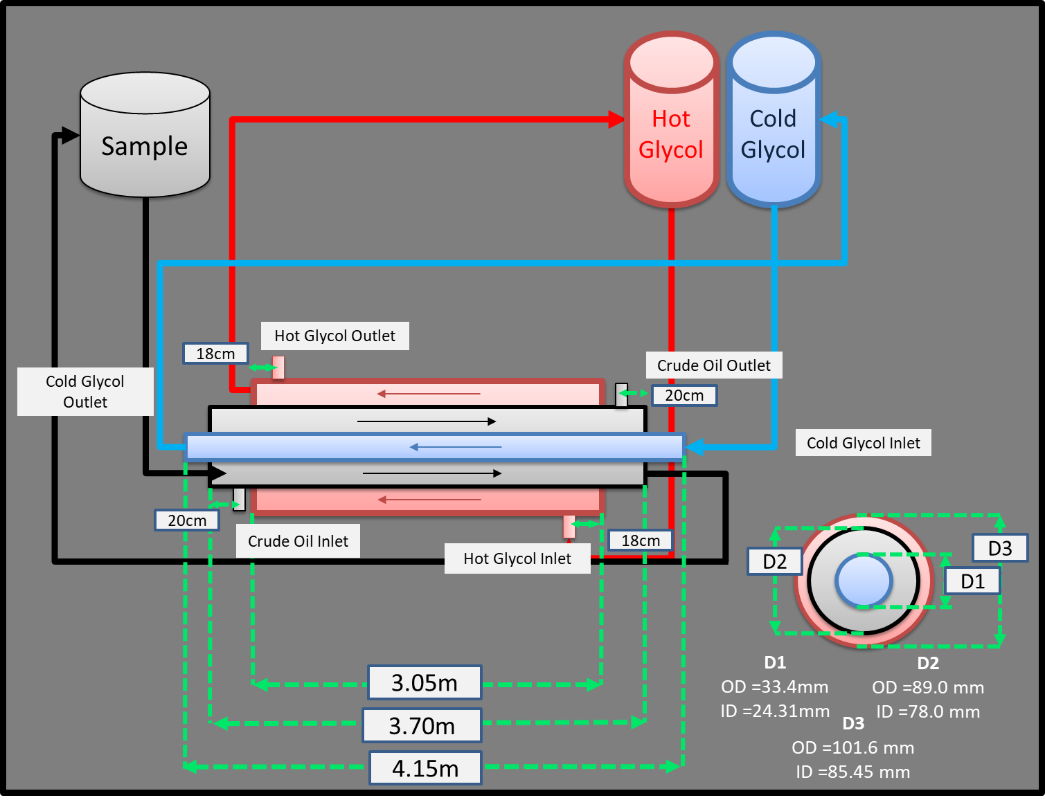

Figure . PRSB’s Wax Flow Loop Configuration and dimension

PRSB’s Wax Flow Loop Configuration and dimension

*T*c,i

*T*o,o

*m*c

*m*o

*m*h

*T*o,i

*T*c,o

*T*h,i

*T*h,o

*L = 3m*



*k*p = 14.4 W/m.K

Wax Deposit

*m*o

*m*c

*d*i

*d*w

Pipe

*T*c,i

*T*o,o

Oil Flow

*T*o,i

*T*c,o

Figure . Flow loop conversion into a normal pipeline

1. Output (Sample)
   * Graphical output (Example)

Basically, the x-axis will be time since the flow loop test section is treated as single section only while the y-axis will be the output from the calculation.

* Table

In table, all inputs, properties values used in the calculation, and outputs values should be provided for each time step.